Herrera, Mark Daniel L.
BSIT 2-F1

Exercise 1

- Create database addressbook
- Describe table_name
- Show databases
- Insert into employee_data values(‘Rudolf’, ‘Reindeer’, ‘Businedd Analyst’, 34, 2, 95000, 17000, ‘rudolf@bugnet.com’)
- Select * From employee_data or Select f_name, l_name, title, age, yos, sslary, perks, email From employee_data
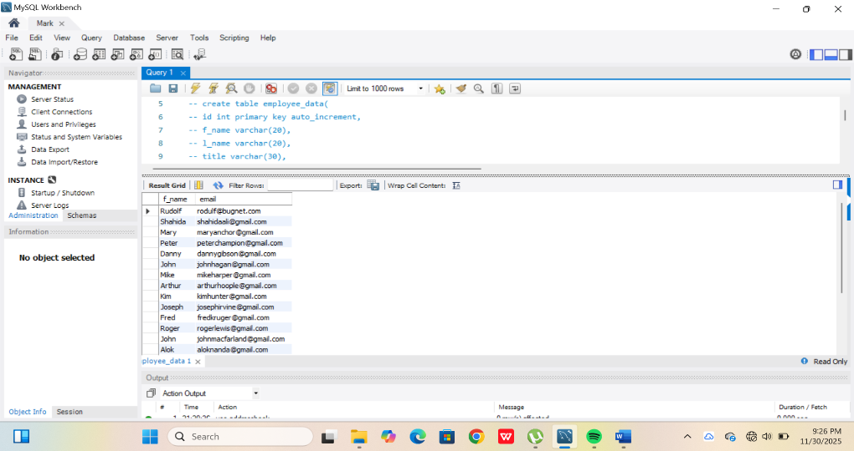

- Select salary, perks, yos From employee_data
- Select count(*) From employee_data
